**ENVIRONMENT MONITORING**

**Project Overview:**

The "Public Park Temperature and Humidity Display" project is designed to enrich the experience of park visitors by offering real-time environmental information, specifically temperature and humidity readings, within the park area. This initiative addresses the crucial need for readily available, current weather data, empowering visitors to make informed choices as they relish their moments in the park.

**Components Required:**

**Hardware Components:**

1. **Arduino Board:**

Select an Arduino board like the Arduino Uno or Arduino Nano to control the project.

1. **DHT Sensor:**

Use a DHT11 or DHT22 sensor for measuring temperature and humidity. These sensors come with libraries for Arduino.

1. **Display:**

Choose an appropriate display to show the temperature and humidity data. Options include:

- 16x2 LCD Display with I2C module (for a simple text-based display).

- OLED Display (for a more graphical and visually appealing display).

- LED Matrix (for a larger and more attention-grabbing display).

1. **Power Supply:**

Depending on your chosen components, you might need a power supply or batteries. Consider using a USB power source or a 9V battery for the Arduino.

1. **Custom PCB:**

You'll need a platform to connect and mount the components. A breadboard is a good option for prototyping, or you can design a custom PCB for a more permanent installation.

1. **Enclosure:**

To protect the electronics from weather conditions, use a weatherproof enclosure. Consider transparent material for displays, so the information is visible.

1. **Cables and Wires:**

Various jumper wires and connectors for connecting the components.

1. **Mounting Hardware:**

Screws, nuts, and brackets for securing the enclosure to a mounting post or structure in the park.

1. **Optional Components:**

**- Resistors and capacitors:** Depending on your sensor and display, you may need additional resistors and capacitors for stability.

**- Voltage Regulator:** If you're using an external power source, a voltage regulator may be required to ensure a stable voltage for the components.

**- Switches:** For turning the display on/off or for resetting the Arduino.

**Software Components:**

1. **Arduino IDE:**

Download and install the Arduino Integrated Development Environment to write and upload code to the Arduino board.

1. **DHT Library:**

Install the DHT sensor library for Arduino. You can find it in the Arduino Library Manager.

1. **Display Libraries:**

If you're using a specific display type (e.g., OLED, LCD), you'll need to install the corresponding libraries for that display.

1. **Custom Code:**

Write the Arduino code to read data from the DHT sensor and display it on the chosen display. You'll need to design the user interface and implement any additional features, like error handling or connectivity.

**Code :**

#include <LiquidCrystal.h>

#include <SimpleDHT.h>

int pinDHT11 = 6;

SimpleDHT11 dht11;

const int rs = 12, en = 11, d4 = 5, d5 = 4, d6 = 3, d7 = 2;

LiquidCrystal lcd(rs, en, d4, d5, d6, d7);

void setup()

{

Serial.begin(9600);

lcd.begin(16, 2);

}

void loop()

{

Serial.println("=================================");

Serial.println("DHT11 readings...");

byte temperature = 0;

byte humidity = 0;

int err = SimpleDHTErrSuccess;

if ((err = dht11.read(pinDHT11, &temperature, &humidity, NULL)) != SimpleDHTErrSuccess)

{

Serial.print("No reading , err="); Serial.println(err);delay(1000);

return;

}

Serial.print("Readings: ");

Serial.print((int)temperature); Serial.print(" Celcius, ");

Serial.print((int)humidity); Serial.println(" %");

lcd.clear();

lcd.setCursor(0,0);

lcd.print("Temp: ");

lcd.print((int)temperature);

lcd.setCursor(0,1);

lcd.print("Humidity(%): ");

lcd.print((int)humidity);

delay(750);

}

**Circuit schematic views :**

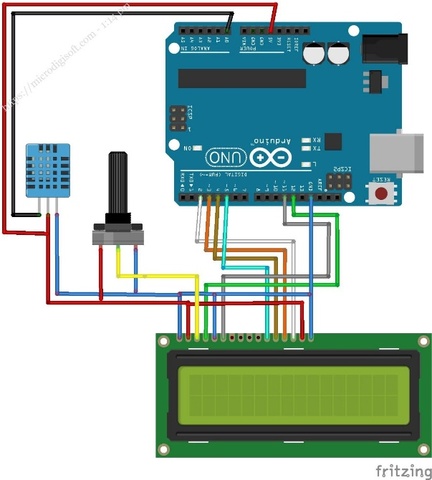

**Conclusion:**

In conclusion, the "Public Park Temperature and Humidity Display" project enhances the park-goers' experience by providing real-time weather data. This innovative addition promotes informed decision-making, educational awareness, and community engagement, ultimately improving the park's appeal and visitor satisfaction.